A000-US-MT-Billings-Blackfoot-Pipe-Beaver-Sun Dance-Black Steatite-c 1950

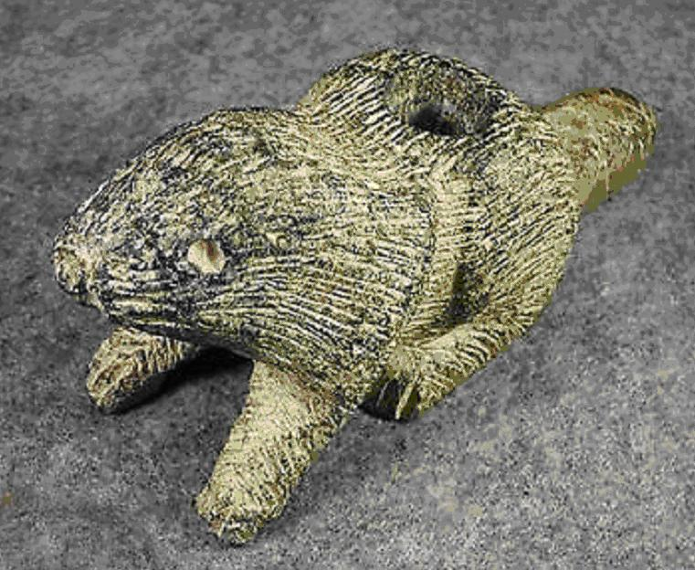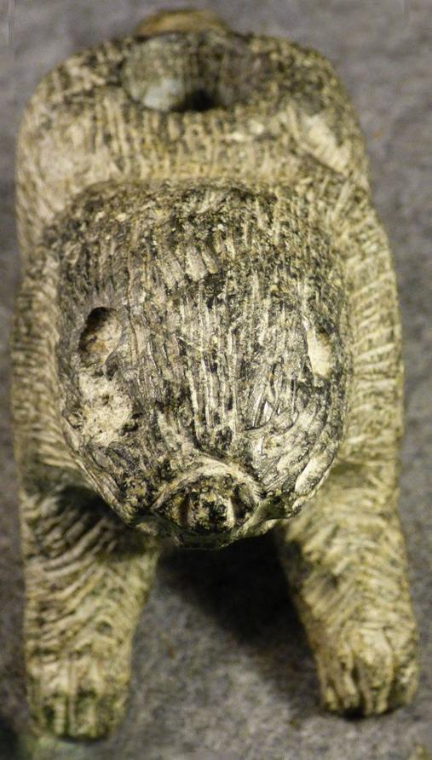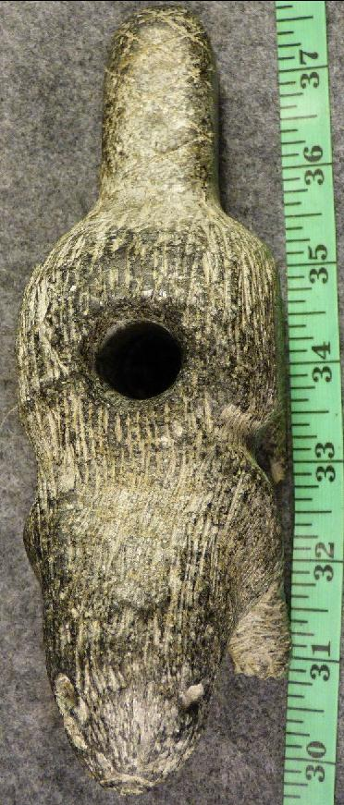

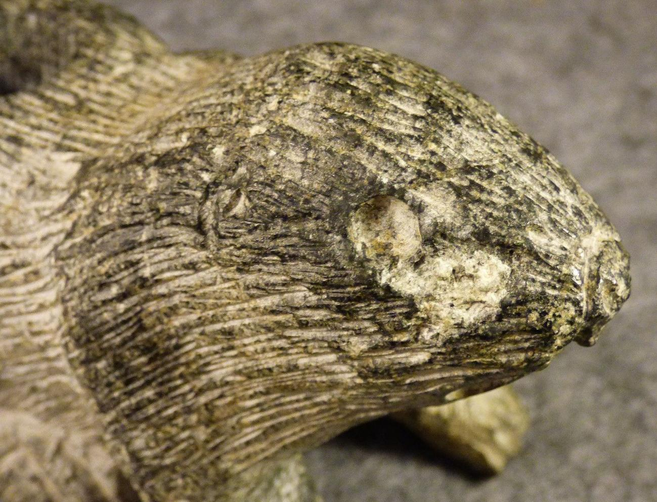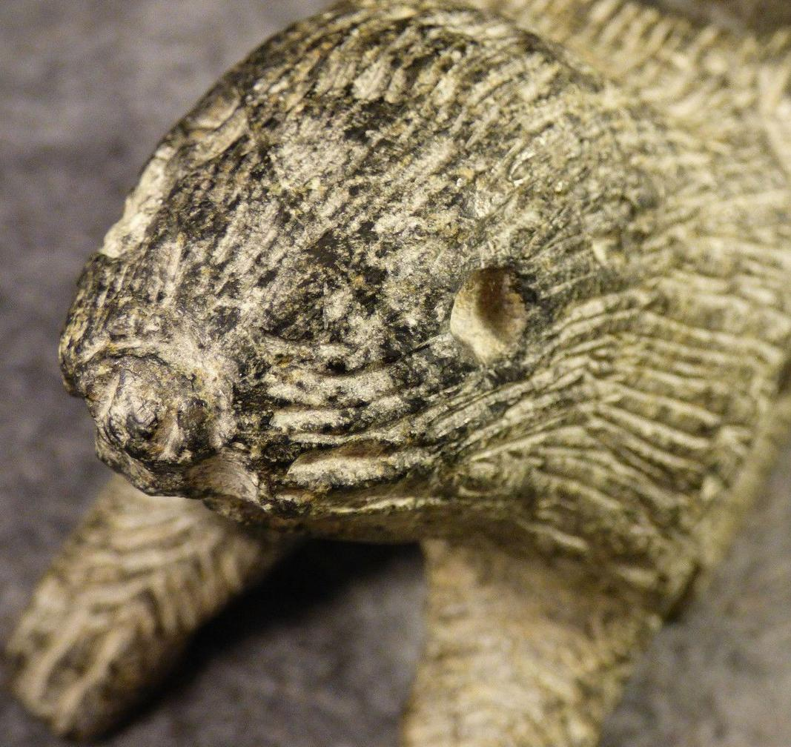

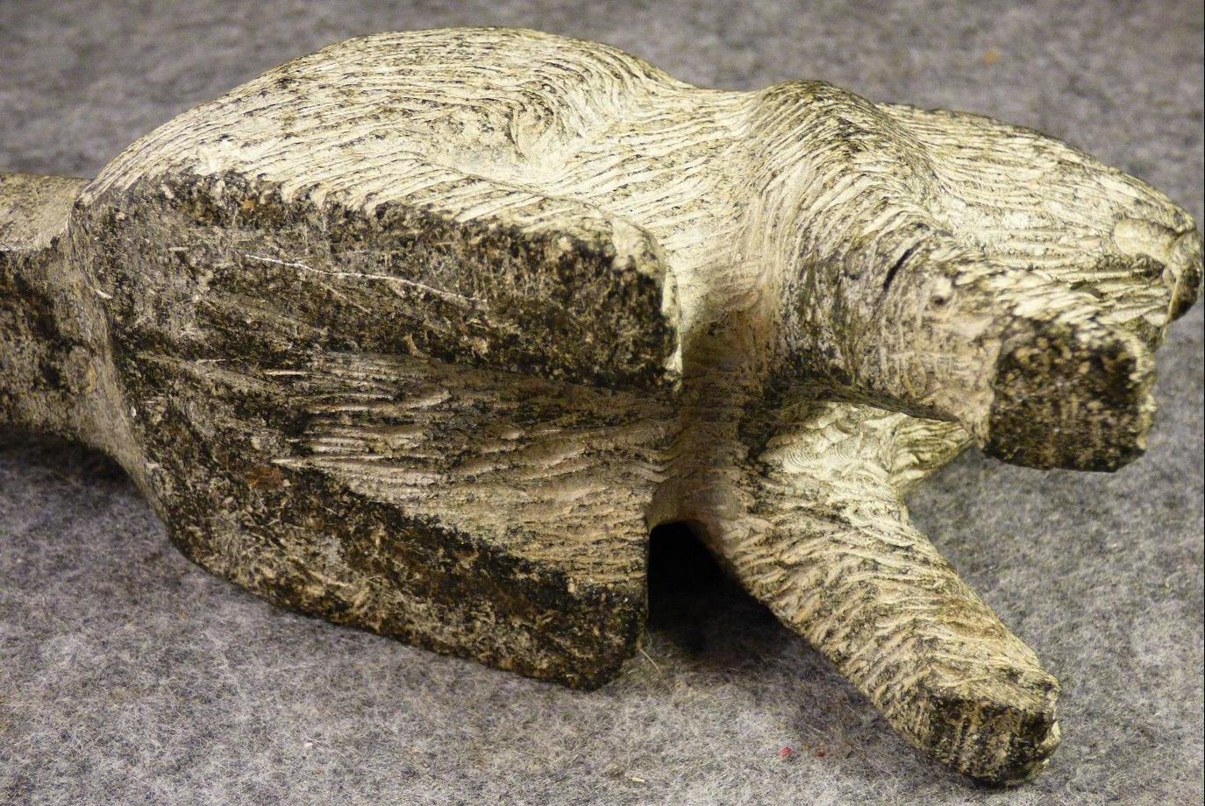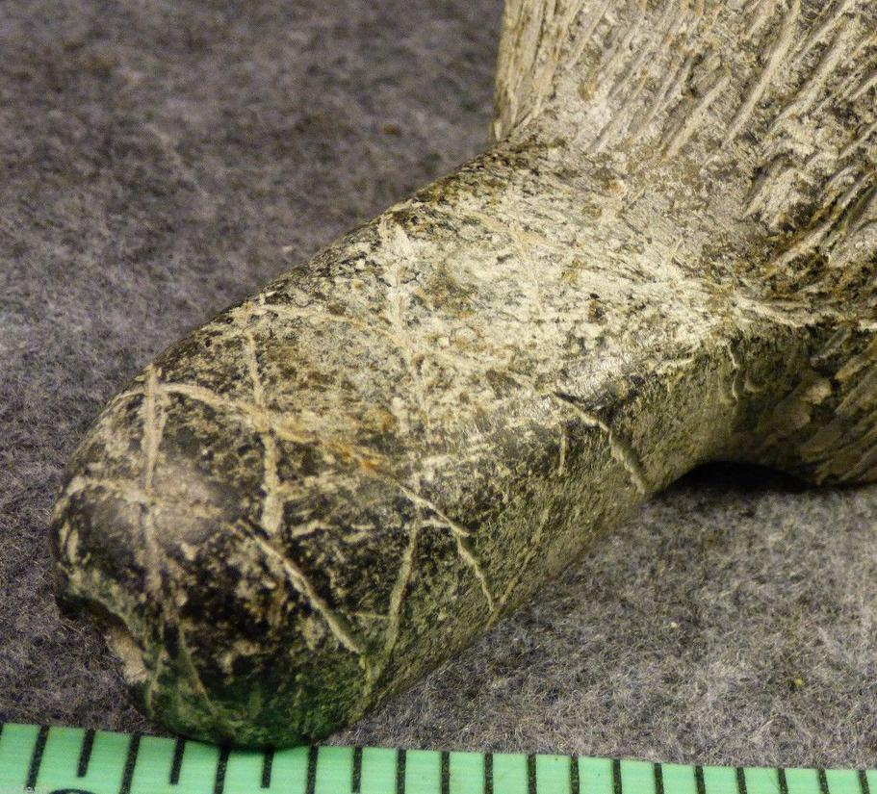

Case No.: 11

**Accession No.**

**Formal Label:** US-MT-Billings-Pipe-Beaver-Sioux-Black Steatite-c 1900

**Display Description:**

For the Blackfoot bison-hunting began to flourish beginning in the 8th c CE with the inception of the Neo-Atlantic Altithermal Climatic Period together with the expansion of the Great Plains as herds of bison exploded onto a lush sea of grasses. It was during this period that the Sun Dance became a major seasonal, communal, religious ceremony. Generally held in late spring or early summer, the rite celebrates-the spiritual rebirth and the regeneration of Nature, including the interactions and social implications of animal ethologies, including the ever social beaver as well as the buffalo, that once enabled lives of the Plains Peoples to flourish, including the Blackfoot (Spier, 1921, p. 459; Liberty, 1980, pp. 165- 66). The Sun Dance was developed to enact renewal of the living earth and the reaffirmation of kinship ties. The beaver gens among the Blackfoor is a pre-eminent case in point because of the intimacy of the beavers in their dens during the seasons and their explicit vigilance to danger when threatened. This pipe, therefore, was made to reinforce this aspect of Blackfoot social life. Therefore, in preparation for the Sun Dance, beaver effigy pipes were smoked by the Blackfoot to reinforce their beaver sense of social ties to their gens before entering into the 0- kee-pa (Okipa) or "look alike" dance in which dancers were identically dressed and painted in the guise not only of bison but also of beavers and other animals (Bowers, 1950, p. 111) whose motions and behaviors they imitated (Catlin 1967, pp. 54-57) which were deemed essential to the well-being of their group.

The other aspect of the Sun Dance and the rôle the beaver played in it (albeit as an auxiliary one) was relieving guilt resulting from the hunters’ killing and eating of sentient creatures. The dilemma was that the Plains Peoples had developed a ubiquitous belief that animals willingly offered their lives to hunters. In accordance with this belief Peoples of the Plains spoke of the hunting of bison not as a drive or a chase but as a calling.

However this belief was not enough to assuage the innate feelings of guilt of these Plains Peoples in their acts of killing, so the Sun Dance was developed to offer atonement to the animals for the harm that was inflicted upon them.



A Blackfoot youth enduring the Sun Dance after Frederic Remington, *Harper's Weekly*, 1890.

The figure above shows a young male Blackfoot being subjected to the ritual of the Sun Dance: after a period of fasting and having four incisions cut vertically into his chest muscles and bone awls inserted horizontally through these incisions rawhide straps are attached to both ends of the awls and the participant, leaning backward against the pull of these rawhide straps attached to a central pole sings songs of atonement until the skin and muscles are ripped from his chest and he is released.

The pain that results is "the natural accompaniment of his figurative death" (Eastman 1970, p. 61) as flesh is ripped away "represents ignorance," which "should always be behind us as we face the light of truth which is before us" (Brown, 1967, p. 86). Thus the Sun Dancer is reborn, mentally and spiritually as well as physically, and the entire universe is renewed as well.

Self-inflicted torture symbolizes represents metaphoric death, after which the initiant is symbolically resurrected, reborn, mentally and spiritually, physically, and the entire universe is renewed as well

This was too powerful a spirituality for the mainly white Christian United States Congress so they outlawed the Sun Dance in 1904, because it went far beyond the commitment that one underwent in a Sunday worship service. It re-enacted the actual ordeal of Christ’s atonement. The Bible was unnecessary. Among a number of tribes antiseptic forms of the ceremony continued, usually as part of the white U. S. Fourth of July celebrations. There were a few tribes in the Upper Midwest, like the Blackfoot, that revived the Sun Dance in its original form and meaning.

After the dancers all tear free, or after four days, the Sun Dance ends. All dancers are laid on sage mats and continue fasting, while they recite visions to the Sun Dance priest, some of which embody new songs, new dances, or prophecies, but the main outcome is a renewal and balance between Nature and all the participants, Sun Dancers and observers alike.

It is in this holistic balance that the beaver metaphorically represents this holism as he seeks to renew its lodge socially as well as physically. The beaver lodge represents, in microcosm, the renewal of the entire universe.

**LC Classification:**

**Date or Time Horizon: c 1950**

**Geographical Area: Billings, MT**

**Map:**

**GPS coordinates:**

**Cultural Affiliation:**

**Medium: black steatite**

**Dimensions:**

**Weight:**

**Condition: original** Excellent condition. No breaks or repairs.

**Provenance: Billings, MT, Estate**

**Discussion:**

The most renowned priest was also the Sun Dance Lodge maker. He ran the entire ceremony and would instruct the participant in building a preparatory tepee and give direction to the other tribesmen who would gather the items needed for the construction. Men known for their eminence in their tribe were chosen to look for a tree with a fork in the top. This was to be for the first and center pole of the lodge. When a suitable tree was located a special qualified person was called in to cut the tree down. The fallen tree was then treated just like a fallen enemy. Then, depending on the tribe a bundle was placed on the fork. In the Sioux tribe the bundle contained brush, buffalo hide, long straws with tobacco in them and other religious offerings.

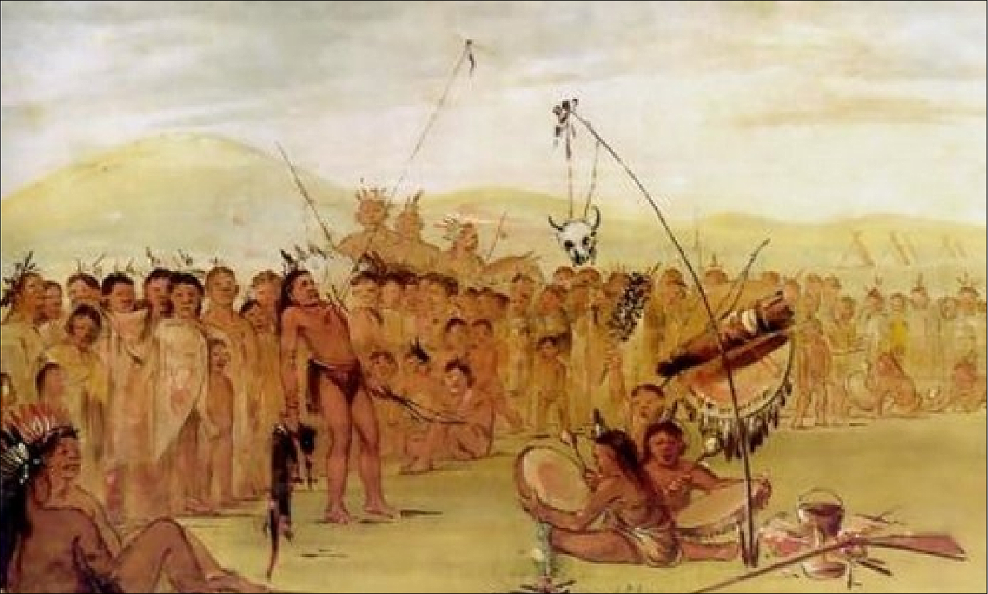

Fig. George Catlin, A Mandan Sun Dance, before 1837.

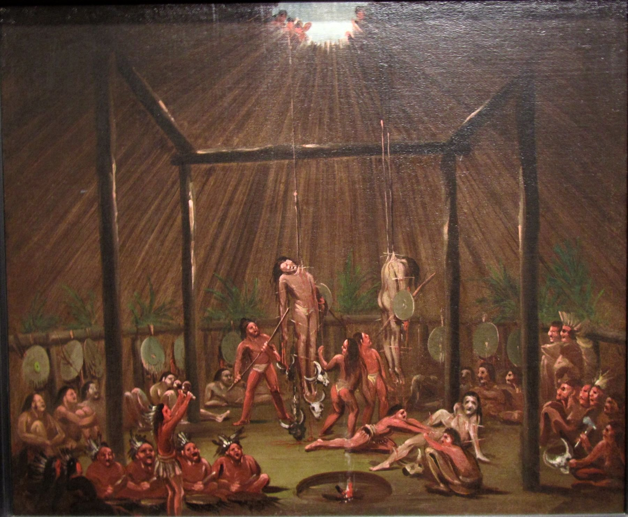

George Catlin, the O-kee-pa ceremony, 1832. https://upload.wikimedia.org/wikipedia/commons/c/c2/'The_Cutting_Scene,_Mandan-O-kee-pa_Ceremony',_oil_on_canvas_painting_by_George_Catlin,_1832.jpg

The eldest woman of the camp leads a group of elaborately dressed maidens to the tree to strip off its branches. The next morning, right as the sun is seen over the eastern horizon, armed warriors charge the sun-pole. They attack the tree in effort to symbolically kill it with gunshots and arrows. Once it is dead it is cut down and taken to where the Sun Dance Lodge will be erected. Before raising the sun-pole, a fresh buffalo head with a broad center strip of the back of the hide and tail (is) fastened with strong throngs to the top crotch of the sun-pole. Then the pole is raised and set firmly in the ground, with the buffalo head facing toward the setting-sun." The tree represents the center of the world, connecting the heavens to the earth.

The lodge is then built by the main dancer and his clansmen.

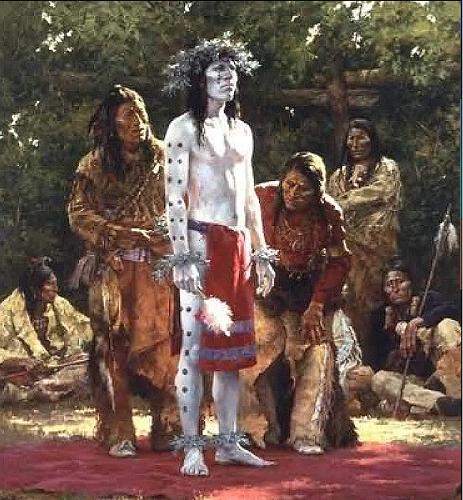

A Dakota Main Dancer covered with white kaolin clay (to protect against the Sun as well as to signify his holiness after purification rites) and then is dotted with black charcoal to signify nothing is totally pure and then is adorned with white bird down (probably from adolescent eagle feathers) on a tiara and wristlets and anklets so that he can fly to the Great Spirit during the Sundance out of body experience. After https://www.native-americans-online.com/images/Howard-Terpning-Prepare-For-Sun-DanceRZ.jpg

The fork of the lodge represents the eagle's nest. The eagle plays a large part in the Sun Dance for it is one of the Plains Indians' most sacred animal. The eagle flies high, being the closest creature to the Sun. Therefore it is the link between man and spirit, being the messenger that delivers prayers to the Wakan-Tanka (god).

In addition to being a messenger, the eagle also represents many human traits. We can see what values and traits these cultures saw as being important in a person by those traits imposed upon such a sacred animal. The eagle is seen as courageous, swift, and strong. He has great foresight and knows everything. "In an eagle there is all the wisdom of the world."

During the Sun Dance the eagle is the facilitator of communication between man and spirit. The Crow may be accompanied by a dancing eagle in his visions, the eagle instructing him about the medicine acquired through the vision. The eagle's feathers can cure illnesses. During the Sun Dance a medicine man may use his eagle feather for healing, first touching the feather to the sun-pole then to the patient, transferring the energy from the pole to the ill people.

It is the buffalo, however, that makes up the main theme of the Sun Dance. In various stories it was the buffalo that began the ritual. The Shoshone believe that the buffalo taught someone the proper way to carry out the dance and the benefits in doing it. Buffalo songs, dances, and feast commonly accompany the Sun Dance.

**References:**

## APPENDIX-Order hidden

## Sales order

Sold by [fortancient](http://myworld.ebay.com/fortancient) ( [410](http://feedback.ebay.com/ws/eBayISAPI.dll?ViewFeedback&userid=fortancient) )

### Delivery package 1 of 1

Estimated delivery Thursday, Apr 21, 2016 - Monday, Apr 25, 2016

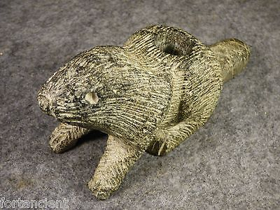

#### [Large Indian Beaver Platform Pipe Highly Detailed Sioux Black Steatite Stone OLD](http://www.ebay.com/itm/252352340993)

## Shipping address

Ralph J Coffman Jr

149 Atlantic Ave

Swampscott MA 01907-2427

United States

**Total**

$224.45

Order placed on

Friday, Apr 15, 2016

Payment method

Credit card

Payment date

Friday, Apr 15, 2016